**SRM Institute of Science & Engineering- Kattankulathur Campus**

**School of Computing**

**B.Tech- 3rd Year**

**Date:** 1st Dec 2020

**Question:**

Mark is asking for the system design of the project work from Alex’s system. For initiating the communication with Alex, he wants to know the exact date and time of Alex’s system. Write a code for Mark, to help him seek the data and time of Alex’s system.

**Aim:**

To implement a TCP/IP day-time server. Once the client establishes connection with the server, the server sends its day-time details to the client which the client prints in its console.

**Procedure:**

*For client:*

* Include the necessary header files.
* Create a socket using socket function with family AF_INET, type as SOCK_STREAM.
* Initialize server address to 0 using the bzero function.
* Assign the sin_family to AF_INET.
* Get the server IP address from the console.
* Using gethostbyname function assign it to a hostent structure, and assign it to sin_addr of the server address structure. ¬ Request a connection from the server using the connect function.
* Within an infinite loop, receive the date and time from the server using the read function and print the date and time on the console.

*For server:*

* + Include the necessary header files.
  + Create a socket using socket function with family AF_INET, type as SOCK_STREAM.
  + Initialize server address to 0 using the bzero function.
  + Assign the sin_family to AF_INET, sin_addr to INADDR_ANY, sin_port to statically assigned port number.
  + Bind the local host address to socket using the bind function.
  + Within a for loop, accept connection request from the client using accept function.
  + Use the fork system call to spawn the processes.
  + Calculate the current date and time using the ctime() function. Change the format so that it is appropriate for human readable form and send the date and time to the client using the write function.

**Program Code:**

*Server Code:*

import socket

import time

def server_program():

# get the hostname

host = socket.gethostname()

port = 3000

server_socket = socket.socket()

server_socket.bind((host, port))

server_socket.listen(2)

conn, address = server_socket.accept()

print("Connection from ~ " + str(address))

while True:

data = conn.recv(1024).decode()

if not data:

break

print("from connected user ~ " + str(data))

data = time.ctime()

conn.send(data.encode())

conn.close()

if __name__ == '__main__':

server_program()

*Client Code:*

import socket

def client_program():

host = socket.gethostname()

port = 3000

client_socket = socket.socket()

client_socket.connect((host, port))

message = input(" ~ ")

while message.lower().strip() != 'bye':

client_socket.send(message.encode())

data = client_socket.recv(1024).decode()

print('Received from server: ' + data)

message = input(" -> ")

client_socket.close()

if __name__ == '__main__':

client_program()

**Output Screenshots:**

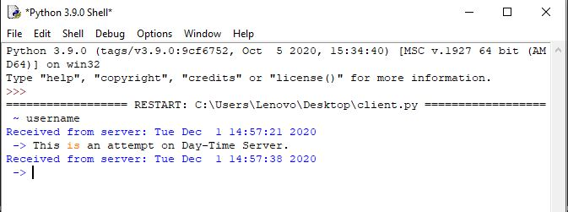

**Client**

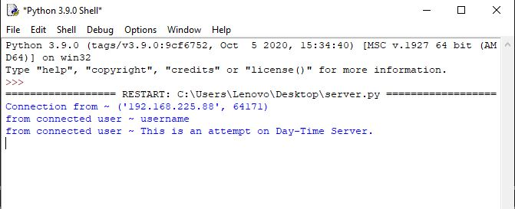

**Server**

**Result:**

Thus, the daytime client- server communication is established by sending the request message from the client to the concurrent server and the server sends its time to all the clients and displays it. In this way, Mark can view the Day, Date and Time of Alex’s system.